**COLLEGE OF COMPUTER STUDIES AND MULTIMEDIA ARTS**

## 

**IT0043L**

**WEB DESIGN WITH CLIENT SIDE SCRIPTING**

**FINAL PROJECT**

**_______________TITLE (of the WEBSITE) _______________ ______________________________________________________________________________________________________**

|  |  |
| --- | --- |
| **Student Name / Group Name:** |  |
| **Members (if Group):** | |  |  | | --- | --- | | **Name** | **Role** | |  |  | |  |  | |  |  | |
| **Section:** |  |
| **Professor:** |  |

1. **PROGRAM OUTCOME/S (PO) ADDRESSED BY THE LABORATORY EXERCISE**

* Apply knowledge with current techniques and tools necessary for the IT profession. [PO: I]
* Ability to use and apply current technical concepts and practices in the core information technologies: human computer interaction, information management, programming and networking and web systems and technologies. [PO: J]

1. **COURSE LEARNING OUTCOME/S (CLO) ADDRESSED BY THE LABORATORY EXERCISE**

* Apply web design principles and fundamentals. [CLO: 2]
* Understand and apply best practices and standards in the development of websites. [CLO: 3]

1. **INTENDED LEARNING OUTCOME/S (ILO) OF THE LABORATORY EXERCISE**

At the end of this exercise, students must be able to:

* + Identify parts of their website using industry practices and standards.
  + Using diagram identify and plan parts of their website as part of their final project.

1. **LABORATORY ACTIVITY**

**Directions:** Plan, design and develop a website and use GitHub as server.

**ACTIVITY 7.1 : Website**

Develop the different parts (html documents) for your website as your final project.

1. **QUESTIONS AND ANSWERS**

**Directions :** Place below each number your answer to each question.

1. Steps in publishing a website in GitHub.
2. Paste below the index.html or landing page of your website using GitHub as server.

URL :

1. Screenshots (ONLY) of working parts of your website. Screenshot also form/s and email submission of data (with data as shown below as example)

Examples:

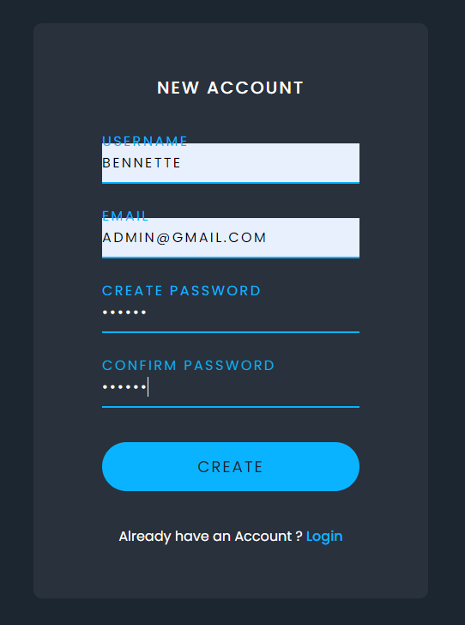

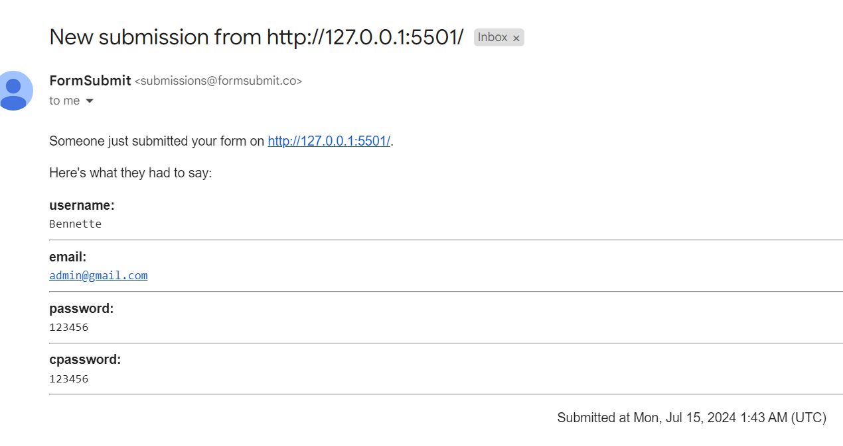

**RUBRIC WEBSITE :**

|  |  |  |  |  |
| --- | --- | --- | --- | --- |
| **Criteria** | **4** | **3** | **2** | **Score** |
| HTML, CSS, JavaScript and Server (Email as Server) | The website was implemented using HTML, CSS, JavaScript and Server (Email as Server) | The website was implemented using HTML, CSS, and JavaScript only. | The website was implemented using HTML and CSS only. |  |
| RESPONSIVE WEB DESIGN | The website was implemented both in Web version and Mobile versions. | The website was implemented both in Web version and some parts in Mobile versions. | The website was implemented both in Web version only. |  |
| WEB DESIGN PRINCIPLES: Home Page | The website provides vital information about the company, its logo and contact details (information). | The website has basic information about the company. | The website has incomplete or vague information. |  |
| WEB DESIGN PRINCIPLES: Level of Web Technology | High Tech Style | Middle of the Road Style | Minimal Style |  |
| WEB DESIGN PRINCIPLES: Page Design and Typography | Website design contains ALL listed below:   * Back to Home link * Consistent template and color scheme on each page * Avoid too large and too small font * Organize your materials to too much scrolling to find content * Place information near the top | Website design contains utmost 4 listed below:   * Back to Home link * Consistent template and color scheme on each page * Avoid too large and too small font * Organize your materials to too much scrolling to find content * Place information near the top | Website design contains utmost 2 listed below:   * Back to Home link * Consistent template and color scheme on each page * Avoid too large and too small font * Organize your materials to too much scrolling to find content * Place information near the top |  |
| WEB DESIGN PRINCIPLES: Visual Hierarchy | Implements website using ALL the “8 Factors that Affect Hierarchy”.  Size, Color, Spacing (Alignment), Repetition, Proximity, Whitespace, Texture and Style | Implements website using utmost 6 of the “8 Factors that Affect Hierarchy”.  Size, Color, Spacing (Alignment), Repetition, Proximity, Whitespace, Texture and Style | Implements website using utmost 4 of the “8 Factors that Affect Hierarchy”.  Size, Color, Spacing (Alignment), Repetition, Proximity, Whitespace, Texture and Style |  |
| Latest Design Trends in Web Design | Uses ALL latest design trends in designing the webpage.  Vibrant Colors, Video and Video Control, Gradients and Duotones, Bold Typography, Animation | Uses utmost 4 of the latest design trends in designing the webpage.  Vibrant Colors, Video and video control, Gradients and Duotones, Bold Typography, Animation | Uses utmost 3 of the latest design trends in designing the webpage.  Vibrant Colors, Video and video control, Gradients and Duotones, Bold Typography, Animation |  |
| Fundamentals of Usability | Implements the website using ALL Fundamentals of Usability.  Clear Navigation, Performance, Readability and Responsiveness | Implements the website using utmost 3 of the Fundamentals of Usability.  Clear Navigation, Performance, Readability and Responsiveness | Implements the website using 2 of the Fundamentals of Usability.  Clear Navigation, Performance, Readability and Responsiveness |  |
|  |  |  |  | ***Total*** |